Question1)
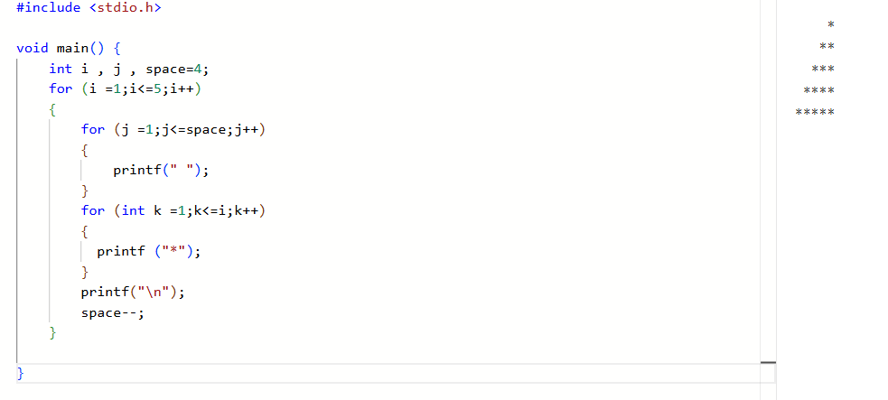

Question2)
#include <stdio.h>

void main() {
int n;
printf("enter the number of elements:");
scanf("%d",&n);
int arr[n];
for (int i = 0;i<n;i++)
{
scanf ("%d",&arr[i]);
}

for (int i = 0;i<n;i++)
{
int pos=i,small=arr[i];
for (int j = i+1;j<n;j++)
{
if (small>arr[j])
{
pos=j;
small=arr[j];
}
}
arr[pos]=arr[i];
arr[i]=small;
}
for (int i = 0;i<n;i++)
{
printf ("%d \t",arr[i]);
}

printf ("\n");
printf("minimum number %d ",arr[0]);
printf ("\n");
printf("maximum number %d",arr[n-1]);
}
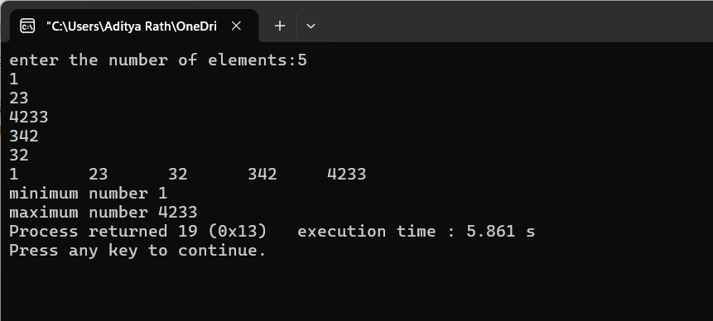

Question3)
#include <stdio.h>

void main() {
int n,b;
printf("enter the number of elements:");
scanf("%d",&n);
int arr[n];
for (int i = 0;i<n;i++)
{
scanf ("%d",&arr[i]);
}
printf("enter the number ");
scanf("%d",&b);
for (int i =0;i<n-2;i++)
{
for (int j =i+1;j<n-1;j++)
{
for (int k =i+2;k<n;k++)
{
if (arr[i]+arr[j]+arr[k]==b)
{
if (j!=i&&i!=k&&k!=j)
{
printf("%d,%d,%d \n",arr[i],arr[j],arr[k]);

}

} }

}

}
}
Output:
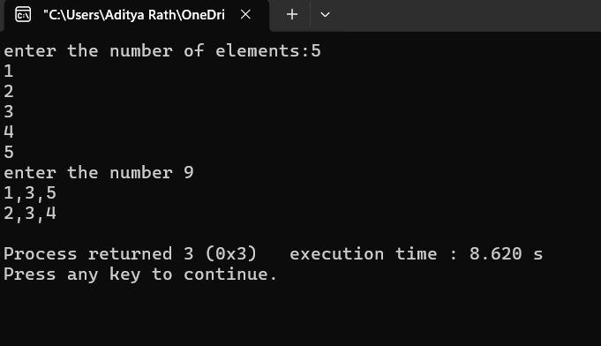

Question4)
#include <stdio.h>

void main() {
int n,b;
printf("enter the number of elements in 1st array:");
scanf("%d",&n);
int arr1[n];
for (int i = 0;i<n;i++)
{
scanf ("%d",&arr1[i]);
}
printf("enter the number of elements in 2nd array ");
scanf("%d",&b);
int arr2[b];
for (int i = 0;i<n;i++)
{
scanf ("%d",&arr2[i]);
}
int arr4[n+b];
for (int i =0;i<n;i++)
{
arr4[i]=arr1[i];

}
int v =0;
for (int i =n;i<n+b;i++)
{
arr4[i]=arr2[v];
v++;

}
for (int i =0;i<n+b;i++)
{
for (int j =i+1;j<n+b;j++)
{
if (arr4[i]>arr4[j])
{
int temp= arr4[j];
arr4[j]=arr4[i];
arr4[i]=temp;
}

}
}
int c=0,arr3[n+b];
printf("\n union :");
for (int i =0;i<n+b;i++)
{

if (arr4[i]==arr4[i+1])
{arr3[c]=arr4[i];
c++;}

else
printf("%d",arr4[i]);
}

printf("\n intersection :");
for (int i =0;i<c;i++)
{

printf("%d",arr3[i]);
}

}

output:
